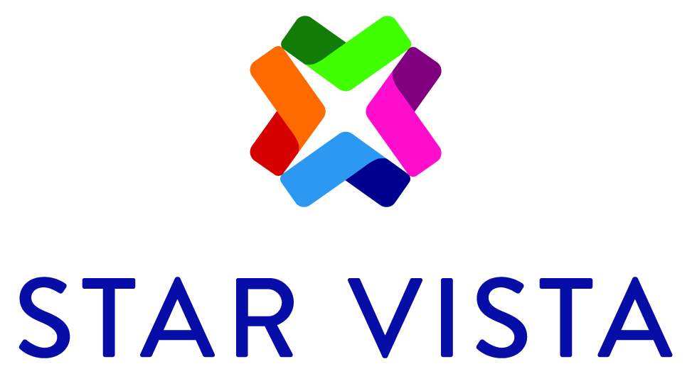

Job Description

Job Title: DUI Program Counselor
Program/ Department: DUI Services
Salary/Wage: DOE, non-exempt
Hours: Part-time

JOB DESCRIPTION:
To provide support and guidance to the clients who are attending our court mandated DUI Program as well as facilitating DUI Groups and conducting Individual Sessions. In addition to this, the DUI Counselor will complete all necessary chart documentation thoroughly and within regulated timelines.

ESSENTIAL JOB FUNCTIONS:
- Conduct Intakes with new clients
- Facilitate First Offender, Multiple Offender, and Education groups
- Conduct quality control audits on client charts
- Retrieve emails daily and correspond as appropriate
- Ensure progress reports are done correctly and on time for Probation
- Monitor group binders to ensure accuracy
- Be available to UA clients when needed for DUI or AOD.
- Attend weekly staff meeting/consultation group
- Type notes in Osiris within 24 hours of service provided
- Accept payments from clients and log appropriately
- Complete ALL paperwork on time including completions, terminations, etc.

REQUIREMENTS:
- Computer Literate & ability to multi-task
- Ability to de-escalate angry/upset clients.
- Excellent written and oral communications skills.
- Positive personal and professional presentation.
- Ability to work with a minimum of direct supervision.
- Skill in assisting clients in a respectful and supportive way
- Ability to work as a team member, when necessary, to accomplish tasks supporting the agency’s mission.
- Be well organized, detail oriented, dependable, punctual, able to produce accurate work
- Must be a registered or certified AOD Counselor or be registry eligible, or a registered AMFT or ASW.

All full-time employees receive medical, dental, vision, and life insurance benefits, accrue three weeks of vacation and two personal days in their first year of employment, and are eligible to participate in a Flexible Spending Account (FSA) and a 401K retirement plan. The agency recognizes 13 paid holidays annually. Benefits for part-time employees are pro-rated according to scheduled hours.

It is our belief that staff diversity promotes appropriate responsiveness to community needs, provides representative role models for all clientele, and improves the quality of our services in a host of ways.

Employment decisions and services provided to clients are not based on race, color, citizenship status, sexual orientation, gender identity or expression, national origin, ancestry, age, religion, creed, disability, marital status, veteran status, or any other characteristic protected by law. StarVista fully supports the Americans with Disabilities Act (ADA) and applicable state disability law.

To Apply: Send Cover and resume to: Janel Guinane, Program Director @ janel.guinane@star-vista.org

