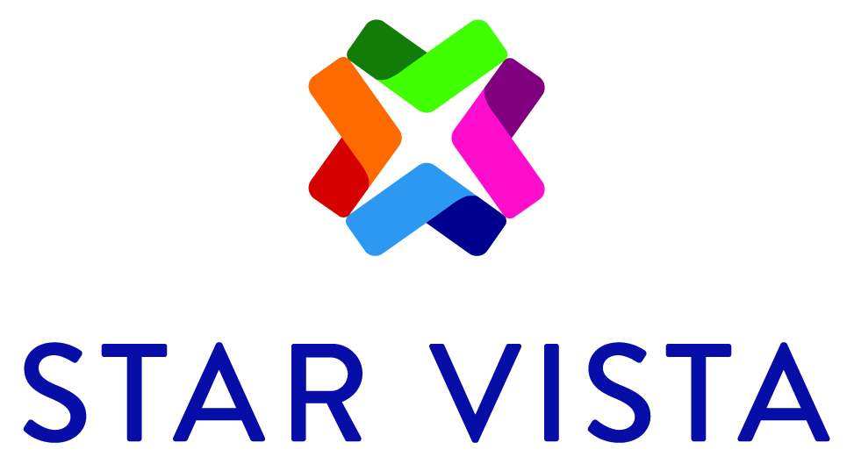

JOB POSTINGS

Job Description: Bilingual Spanish Mental Health Clinician
Program/ Department: GIRLS Program/Youth Empowerment Services
Salary/Wage: DOE
Status: 20-30 hours, non- exempt (includes partial or full-time benefits)
Possibility for Full-time (40 hours) position in collaboration with another StarVista program
PROGRAM DESCRIPTION: The GIRLS Program is an outpatient treatment program for adolescents who are either incarcerated at the Youth Services Center, Camp Kemp or who are on probation. GIRLS is uniquely designed to address substance abuse and mental health issues with a strong focus on the treatment of trauma working closely with San Mateo County Behavioral Health and Recovery Services and Probation. GIRLS provides group, individual and family therapy. Group therapy is typically from 3:00pm to 4:15pm with individual and family therapy provided usually between 3:00pm and 7:00pm (occasionally until 8:00pm). Multi-family group is offered every other Saturday morning. Clients attend treatment up to five days a week and for a minimum of 6 months and typically for at least a year. Therapy groups address topics including recovery, trauma, emotional regulation, health and wellness, parenting, and other life skills. We use a wide range of modalities to provide holistic, strength-based treatment.

Clinicians provide group therapy, individual therapy and family therapy and case management. Applicants need to be comfortable working as part of a multi-disciplinary team with clients with challenging issues and working as part of a team at GIRLS. Ideally a clinician would have experience with group therapy, individual, and family therapy and of working with trauma.

The GIRLS staff work closely together as a team. Clinicians would gain in depth experience of working with complex client cases in a very supportive environment. They will have the opportunity to develop group therapy skills and to work with adolescent clients mandated to treatment. In addition to the required 1 hour individual supervision each week, clinicians receive 2 hours each week of group supervision. Clinicians have access to relevant San Mateo County trainings, which include trainings on for example Law and Ethics, Motivational Interviewing, Suicide Prevention, Trauma-informed care, and anxiety treatment.

Clinicians will gain experience with Medi-Cal documentation requirements and the San Mateo county electronic medical records system (Avatar).

MINIMUM QUALIFICATIONS: Bilingual Spanish, registered AMFT or ASW, predoctoral or postdoctoral intern, team player, group therapy experience, available Monday to Thursday late morning to evening hours with every other Saturday morning, able to pass fingerprint clearance.

PREFERED QUALIFICATIONS: Working with adolescents with trauma, family therapy, substance use, mandated clients, working in a milieu or intensive treatment setting. Experience liaising with a client’s multi-disciplinary team. Medi-Cal and Avatar experience.

TO APPLY: To apply, please send a cover letter and resume to Dr. Catarina Juan Simon at catarina.juansimon@star-vista.org

Posted 6/25/2019

